**1-Introduction**

The global landscape of agricultural production is multifaceted , woven by the collective efforts of nations striving to meet the ever-growing demand for food and feed. Understanding the dynamics of this intricate system is essential for addressing challenges related to food security, resource allocation, and sustainability.

This study delves into the diverse realms of worldwide agricultural production, employing a comprehensive dataset sourced from Kaggle. The dataset spans the years 1961 to 2013, encapsulating a significant timeframe of global agricultural activities. The exploration uses prominent Python libraries, including scikit-learn (sklearn), numpy, matplotlib, pandas, and statsmodels.

In this endeavor, we aim to examine the variety in items produced by different countries, ascertain correlations between a country's total agricultural production and the percentage of production allocated to human food, and investigate the dependencies on food production vis-a-vis feed production. Additionally, the objectives involve ranking countries based on their total production and identifying the agricultural products that dominate or lag in production.

**2-goals**

-determining the variety in items produced by countries.

-calculating correlation between country's sum production and the human food production percentage.

-exploring granger causality between country's sum production and the human food production percentage.

-studying countries' dependance on food production compared to feed production.

-ranking the countries' based on total production.

-examining the most / least produced agricultural products.

-concluding which countries produce the most of the most / least produced agricultural products.

**3-findings**

1-Spain and Italy produce the most variety of agricultural products, while Lesotho and Afghanistan produce the least variety.

Countries ranked by variety of items produced


2-Worldwide, food is produced more than feed. Agricultural production is increasing yearly,

and food production is growing at a faster rate than feed production.

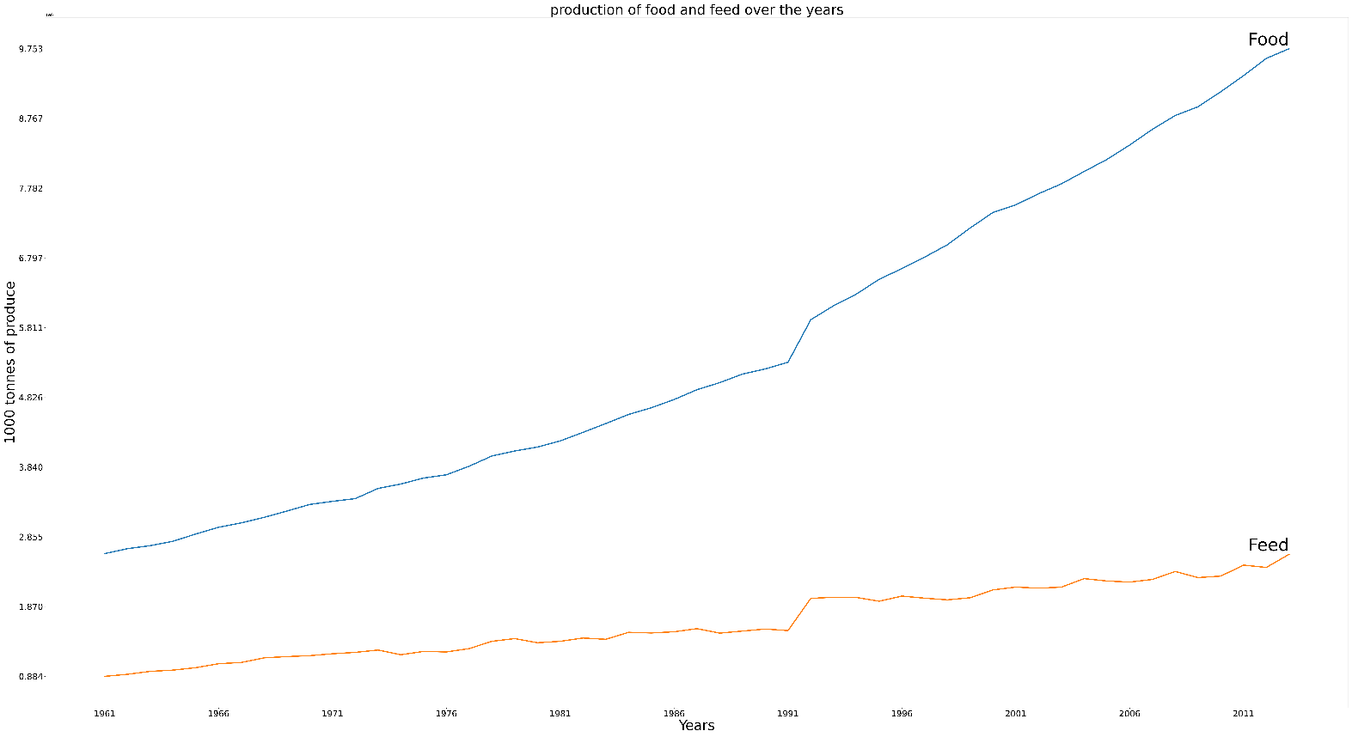

3-Correlation between the percentage of food production in a country and its total agricultural production exists negatively in most countries and positively in some countries.

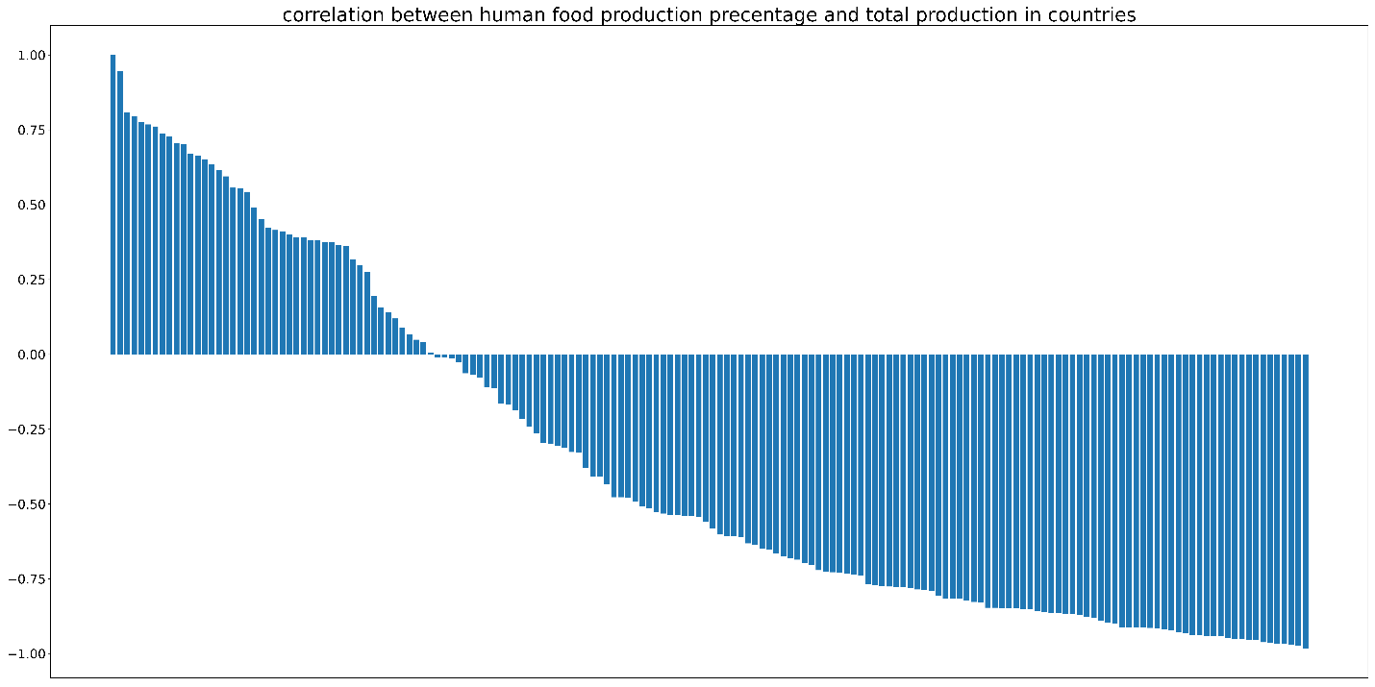

4-The majority of countries' total production isn't Granger caused by food production percentage,

but a significant percentage is.

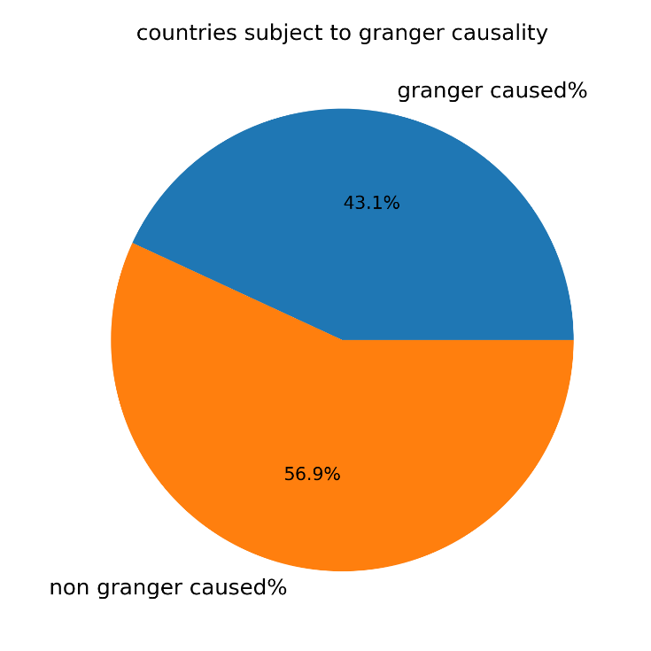

5-Agricultural production is a complex and multifaceted topic;

correlation between these elements could be attributed to correlation with a third element or more outside of this dataset.

6-Most countries have at least a 50% food production percentage out of total production,

with the exceptions of Poland at 49.7%, Belarus at 42%, and Denmark at 36.8%.

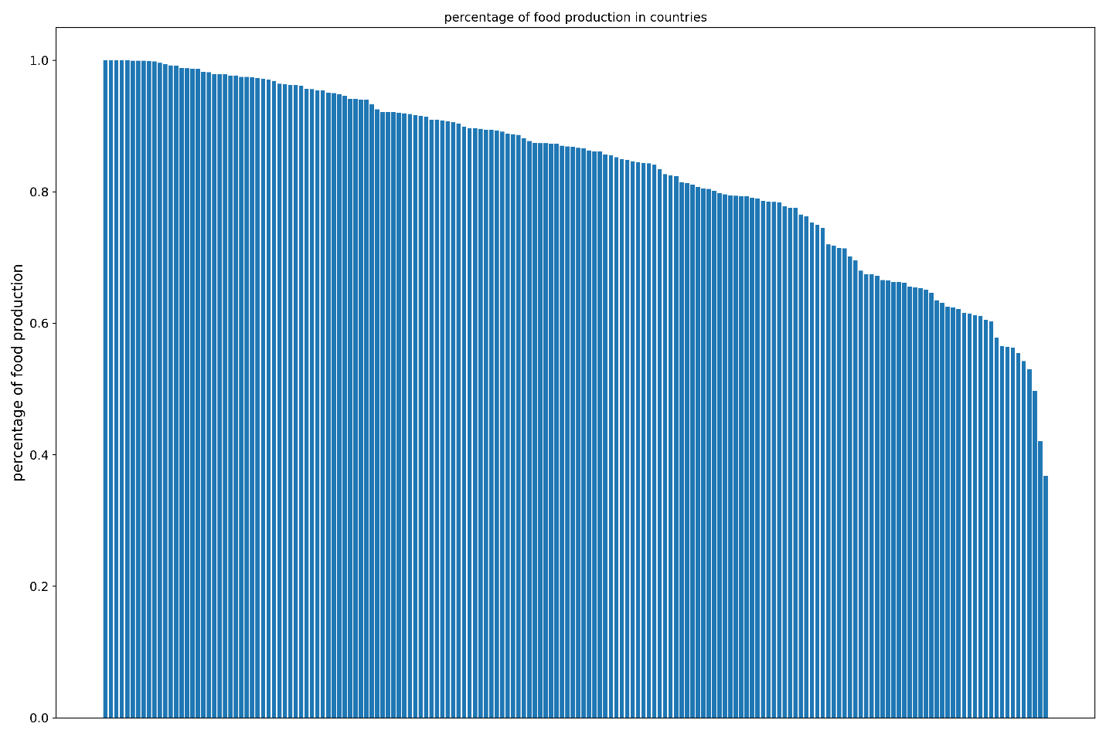

7-Most countries have less than 100% food production percentage out of total production,

with the exceptions of Sao Tome and Principe, Solomon Islands, Saint Kitts and Nevis, and Maldives at 100%.

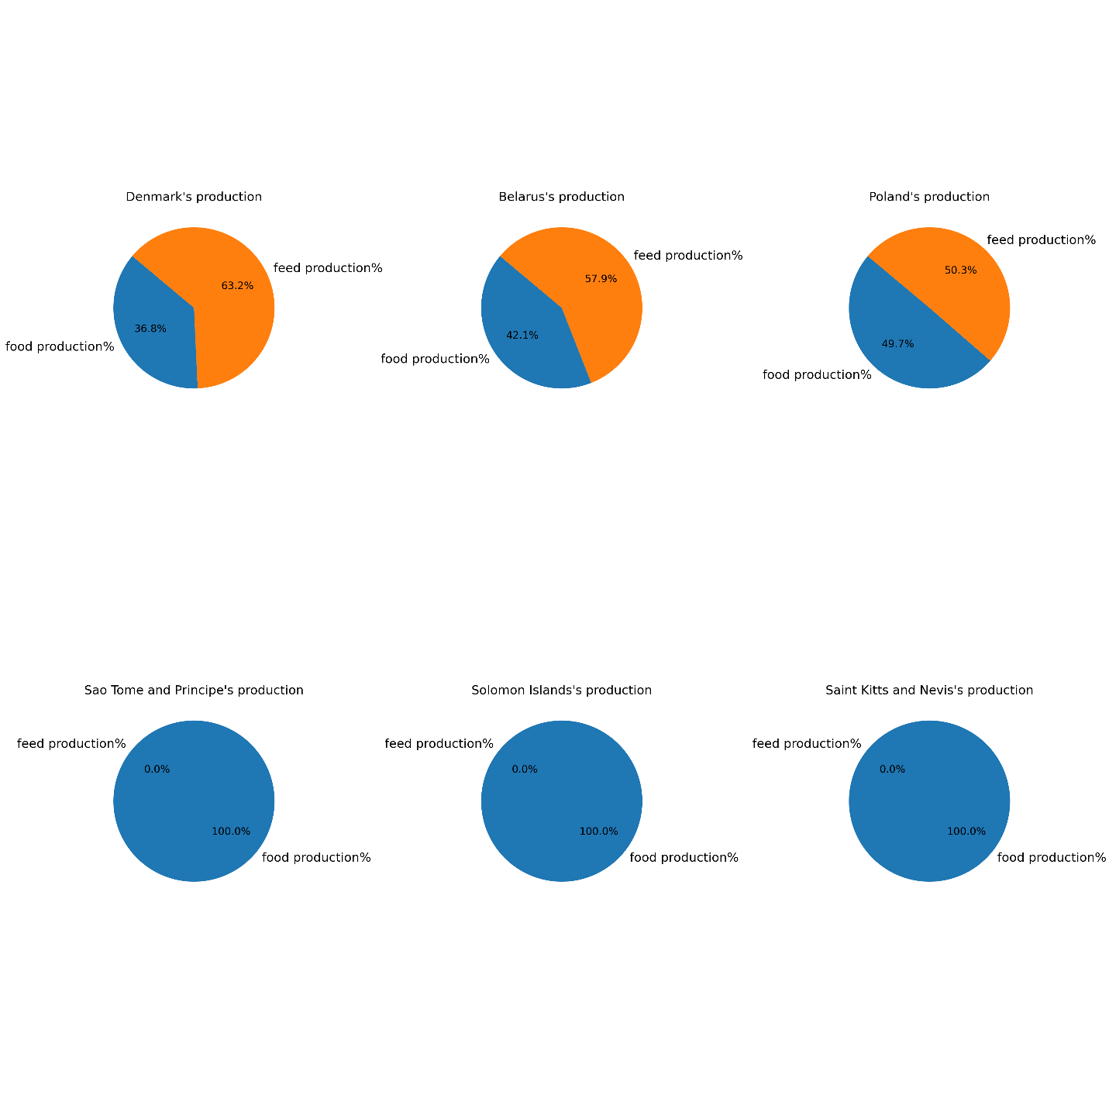

8-China, USA, and India have the most agricultural product over the period from 1961 to 2013,

while Antigua and Barbuda, Kiribati, Saint Kitts and Nevis have the least.

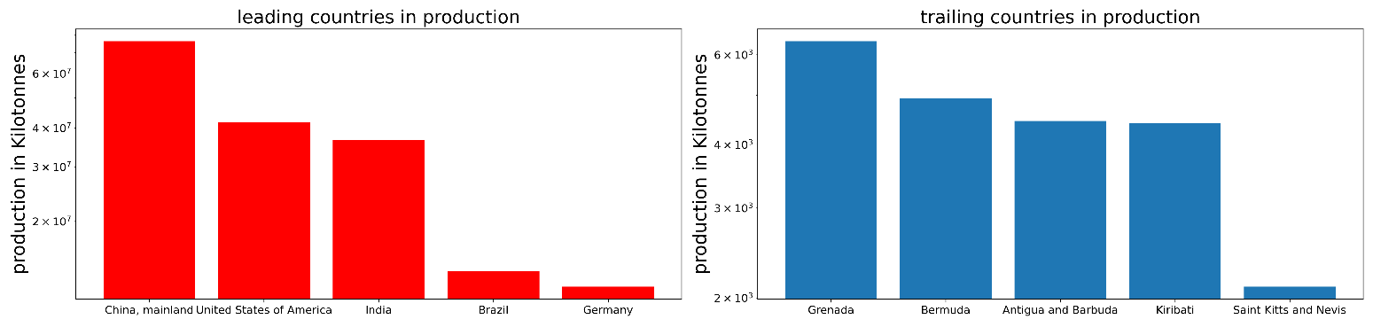

9-[Cereals - Excluding Beer] (food) 36 billion tonnes, [Cereals - Excluding Beer] (feed) 28 billion tonnes, and [Vegetables] (food) 23 billion tonnes

are the most produced agricultural products over 1961 – 2013.

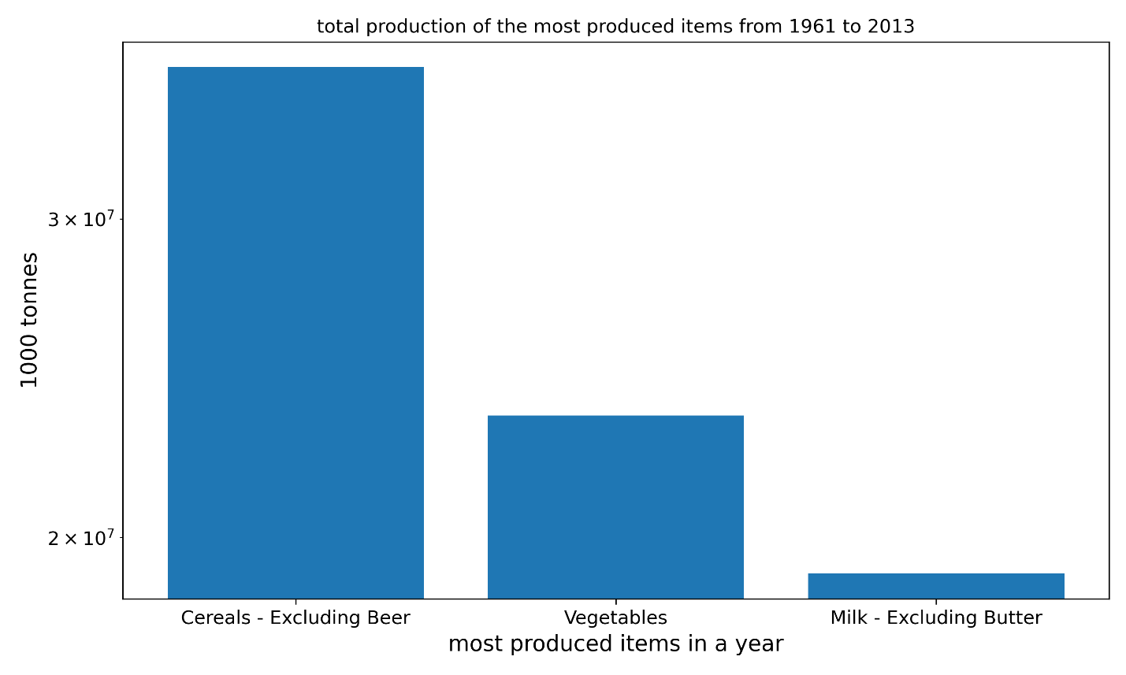

10-[Palm Kernels, Oil crops, and Olive Oil] (feed) are the least produced at 20 thousand tonnes combined.

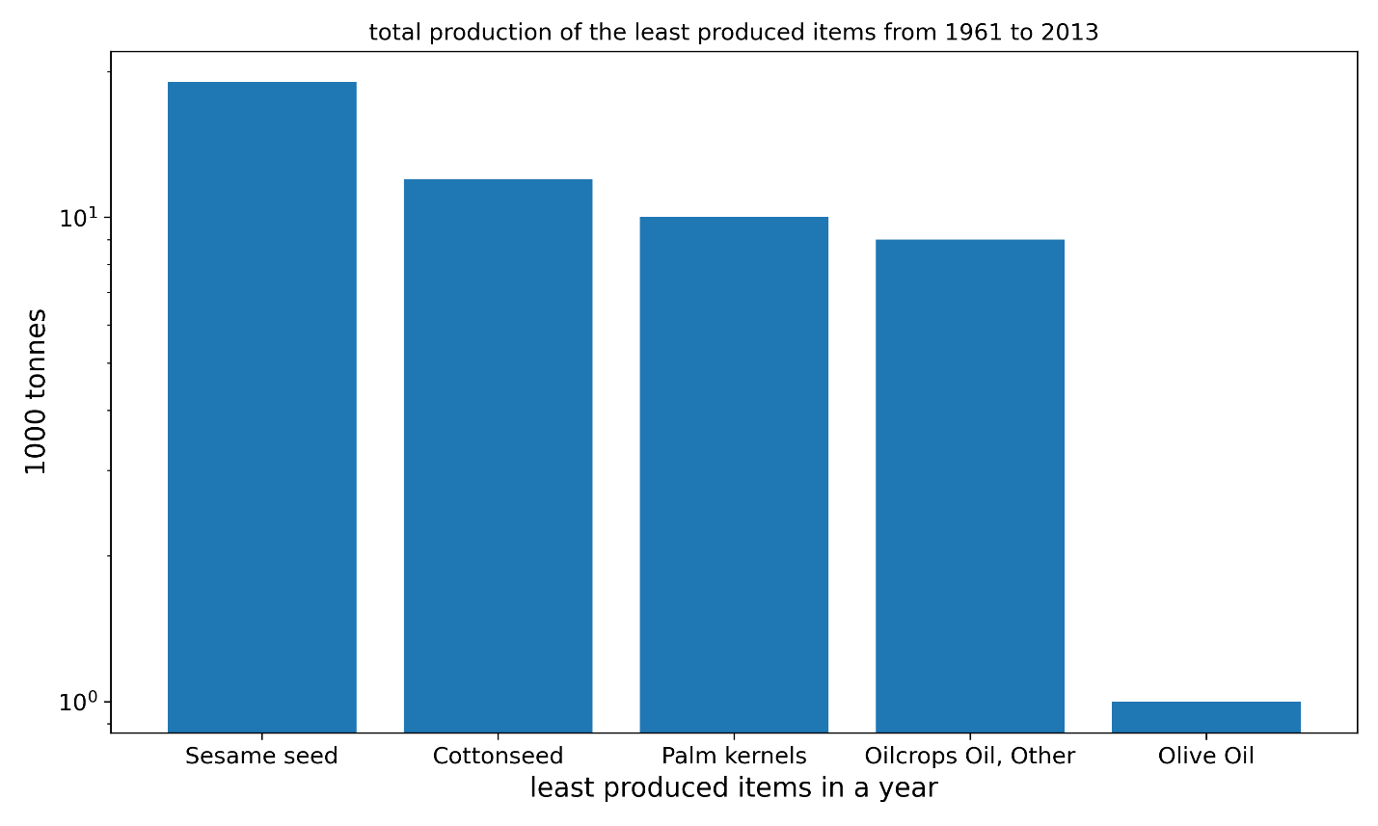

11-China is the largest producer every year of [Cereals - Excluding Beer] (food).

From 1961 to 1988,

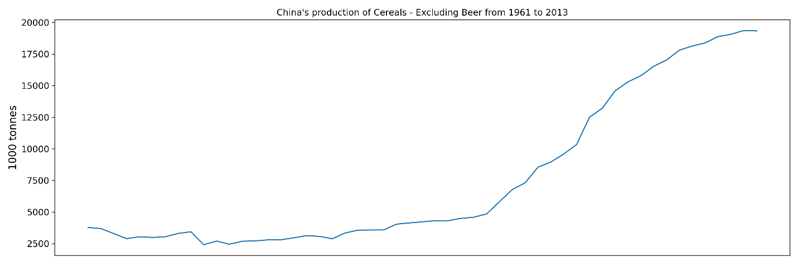

12-Germany was the largest producer of sugar beet every year; then from 1988 to 2013, it was either Colombia or Venezuela.

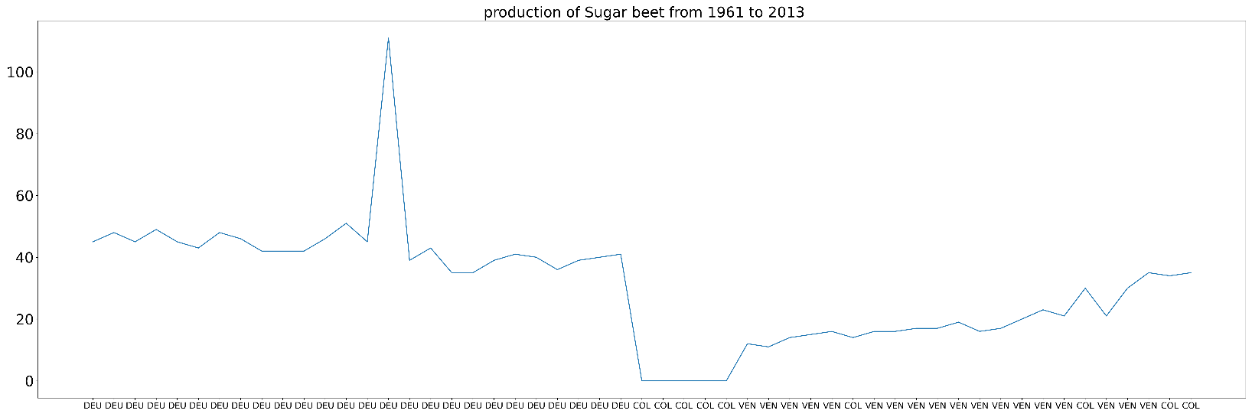

**4-data source and libraries used.**

source: https://www.kaggle.com/datasets/dorbicycle/world-foodfeed-production

python: 3.8.8

libraries:

scikit-learn (sklearn): 0.24.1

numpy: 1.22.4

matplotlib: 3.3.4

pandas: 1.2.4

statsmodels: 0.12.2